Waiver No:  ALT INTERNAL USE | Requester:  Fii
Model / Hardware Version / Software Version :
Model: BFX-UA300
PCBA revision: v115
Software version:
Title: Waive the USB3.0 hot-plug detect test issue in VS-550 platform
Request Date: 2021/06/21  Expiration Date: (Options) | Expiration Notes:(Options)
Related Specification:
No related specification
Problem Description
After booting, insert the USB sticker by using specific model (ex. Kingston 32GB, DataTraveler 100 G3 3.0) and the memory stick will be not detected. And then try to unplug and plug several time, but it is still not detected

Technical Impact / Limitation:
- Fii have performed the USB2.0/3.0 SI & drop test, and got pass result. Based on the previous experience, it gives us enough confidence on the stability of the product
- Fii have provided SoC block diagram and USB signal switch schematics to Synaptics HW FAE Xiaomin review. And there is no any problem be found.

Customer or User Impact:
The USB3.0 hot-plug detection failure rate is about 1%

Proposed Resolution:
Solution: Pull down 10K resistor for the enable pin of USB3.0 power switch + 22uF*3 + register value of 0xF7A2503C[5:1] applied from 0X10 to 0x0A
Verification result tested by Fii SQA & RD
- DUT1: failure rate 2/200
- DUT2: failure rate 3/200
- DUT3: failure rate 0/200

Evidence / Vender report / Remarks:
(Options)
- Attach USB3.0 SI report and drop & overload test report.
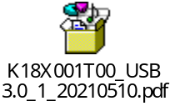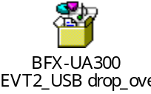

- Attach vendor Synaptics’s comment
